Университет ИТМО

Факультет ФПИ и КТ

### Отчёт

### по лабораторной работе 3

# «Численное интегрирование»

Вариант 10

Студент:

Преподаватель:  
Малышева Татьяна Алексеевна

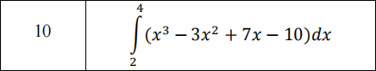

$$\int_{2}^{4}{(x^{3}−3x^{2}+7x−10)dx=\frac{1}{4}x^{4}−x^{3}+\frac{7}{2}x^{2}−10x|_{2}^{4}}$$

=26

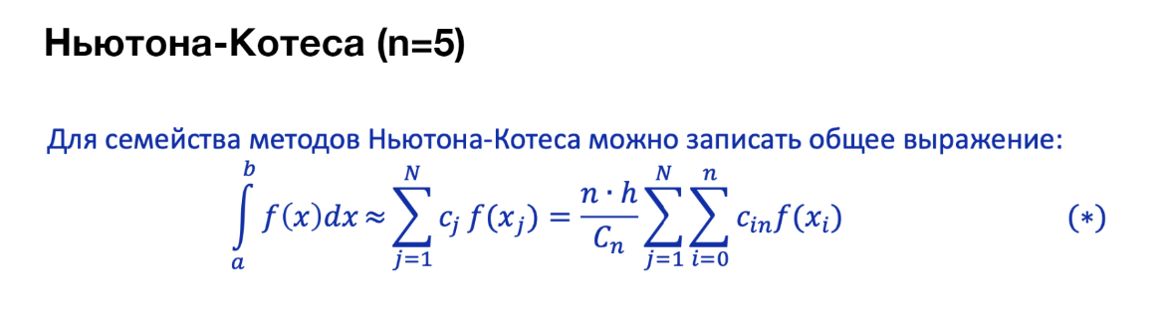

|  |  |  |  |  |  |  |  |
| --- | --- | --- | --- | --- | --- | --- | --- |
| n | $$c_{n}$$ | $$c_{0n}$$ | $$c_{1n}$$ | $$c_{2n}$$ | $$c_{3n}$$ | $$c_{4n}$$ | $$c_{5n}$$ |
| 0 | 1 | 1 |  |  |  |  |  |
| 1 | 2 | 1 | 1 |  |  |  |  |
| 2 | 6 | 1 | 4 | 1 |  |  |  |
| 3 | 8 | 1 | 3 | 3 | 1 |  |  |
| 4 | 90 | 7 | 32 | 12 | 32 | 7 |  |
| 5 | 288 | 19 | 75 | 50 | 50 | 75 | 19 |

H= $\frac{4−2}{5}=0.4$

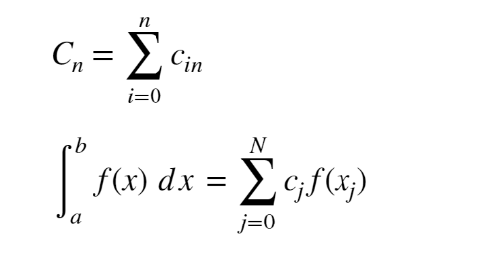

|  |  |  |  |  |  |  |
| --- | --- | --- | --- | --- | --- | --- |
| $$j$$ | $$x_{j}$$ | $$y_{j}$$ | $$c_{j}∗f(x)$$ | $$h$$ | $$a$$ | $$b$$ |
| $$0$$ | 2 | 0 | 0 | $$0.4$$ | $$2$$ | $$4$$ |
| $$1$$ | 2.4 | 3.344 | 250.8 |
| $$2$$ | 2.8 | 8.032 | 401.6 |
| $$3$$ | 3.2 | 14.448 | 722.4 |
| $$4$$ | 3.6 | 22.976 | 1723.2 |
| $$5$$ | 4 | 34 | 1805 |
| $$6$$ | answers | | 3744*(4-2)/288=26 | | | |

Погрешность: 0%



**Метод прямоугольников**

|  |  |  |  |
| --- | --- | --- | --- |
| i | xi | yi | h |
| 0 | 2.1 | 0.731 | 0.2 |
| 1 | 2.3 | 2.397 |
| 2 | 2.5 | 4.375 |
| 3 | 2.7 | 6.713 |
| 4 | 2.9 | 9.459 |
| 5 | 3.1 | 12.661 |
| 6 | 3.3 | 16.367 |
| 7 | 3.5 | 20.625 |
| 8 | 3.7 | 25.483 |
| 9 | 3.9 | 30.989 |
|  | answer | 25.96 | |
|  | Погрешность | 0.0016% | |

**Метод трапеций**

|  |  |  |  |
| --- | --- | --- | --- |
| i | xi | yi | h |
| 0 | 2 | 0 | 0.2 |
| 1 | 2.2 | 1.528 |
| 2 | 2.4 | 3.344 |
| 3 | 2.6 | 5.496 |
| 4 | 2.8 | 8.032 |
| 5 | 3 | 11 |
| 6 | 3.2 | 14.448 |
| 7 | 3.4 | 18.424 |
| 8 | 3.6 | 22.976 |
| 9 | 3.8 | 28.152 |
| 10 | 4 | 34 |
|  | answer | 26.08 | |
|  | Погрешность | 0.003% | |

**Формула Симпсона**

|  |  |  |  |
| --- | --- | --- | --- |
| i | xi | yi | h |
| 0 | 2 | 0 | 0.2 |
| 1 | 2.2 | 1.528 |
| 2 | 2.4 | 3.344 |
| 3 | 2.6 | 5.496 |
| 4 | 2.8 | 8.032 |
| 5 | 3 | 11 |
| 6 | 3.2 | 14.448 |
| 7 | 3.4 | 18.424 |
| 8 | 3.6 | 22.976 |
| 9 | 3.8 | 28.152 |
| 10 | 4 | 34 |
|  | answer | 26 | |
|  | Погрешность | 0 | |